Data Science, 2022

Tut 4: Independent Component Analysis
Ex. 1
Exercise: Mixing statistically independent sources
Given some scalar and statistically independent random variables (signals) si with zero mean, unit variance,
and a value ai for the kurtosis that lies between −a and +a, with arbitrary but fixed value of 0 < a. The si
shall be mixed like
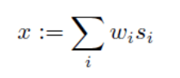
with constant weights w_{i}.
- Which constraints do you have to impose on the weights w_{i}.to guarantee that the mixture has unit variance as well?
Hint
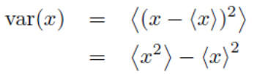

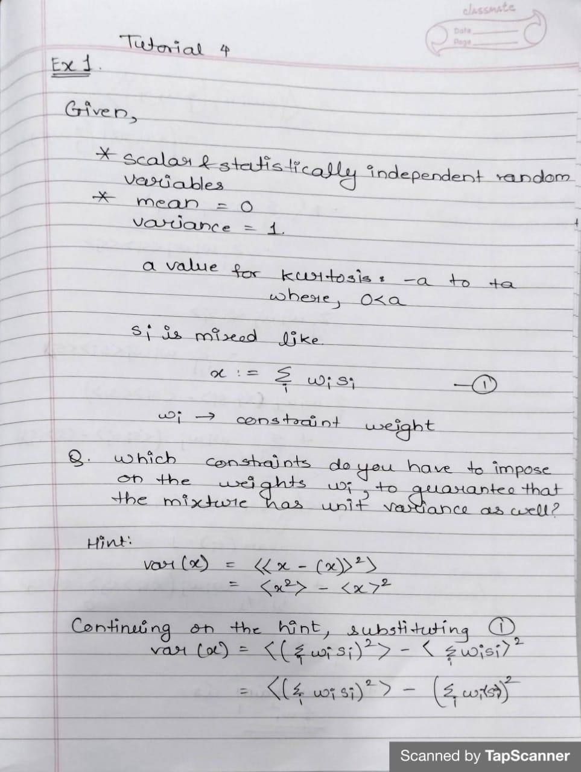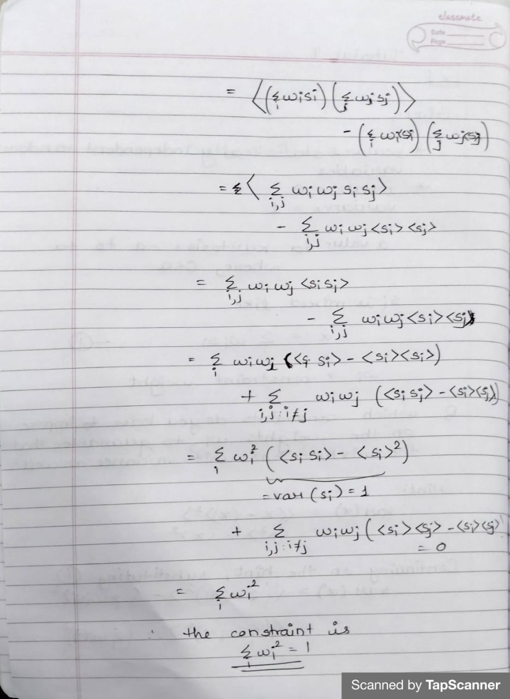
Ex.2
Two examples of joint probability densities are shown in following figure. One is a mixture of arbitrary non-Gaussian densities, and the other one a mixture of Gaussians. The dashed curves around the densities plot the projected variance measured in all directions. The dashed line marks the direction of maximum variance, that is, the first principal component. Similarly, the values of kurtosis are shown using solid curves and the direction of maximum kurtosis with a solid line.
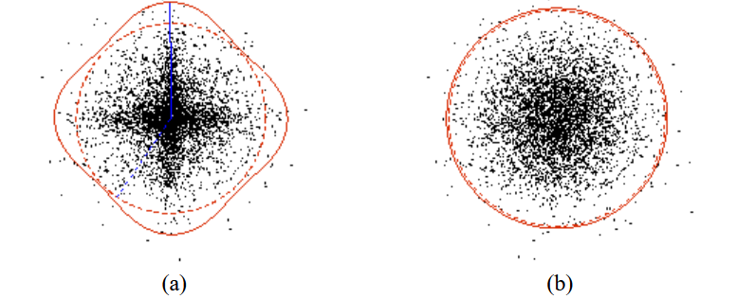
Example joint propability densities. (a) For non-Gaussian densities the principal (dashed line) and independent (solid line) directions can be identified, where as (b) for Gaussian ones the directions are all equal. The corresponding dashed and solid curves show the values of variance and kurtosis in all directions respectively.
Referring to above provide the guess independent components and distributions from data
- Decide whether the following distributions can be linearly separated into independent components. If yes,
- sketch the (not necessarily orthogonal) axes onto which the data must be projected to extract the independent components. Draw these axes also the marginal distributions of the corresponding components.
